1.4.7 Image PROJECT

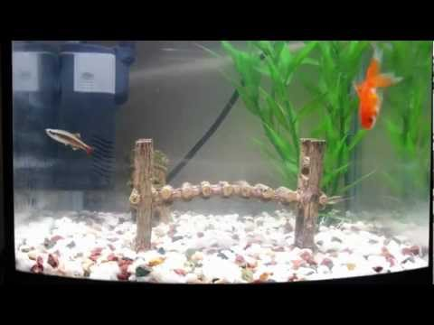

This is the original photo without the changes.

This added a shark to the water tank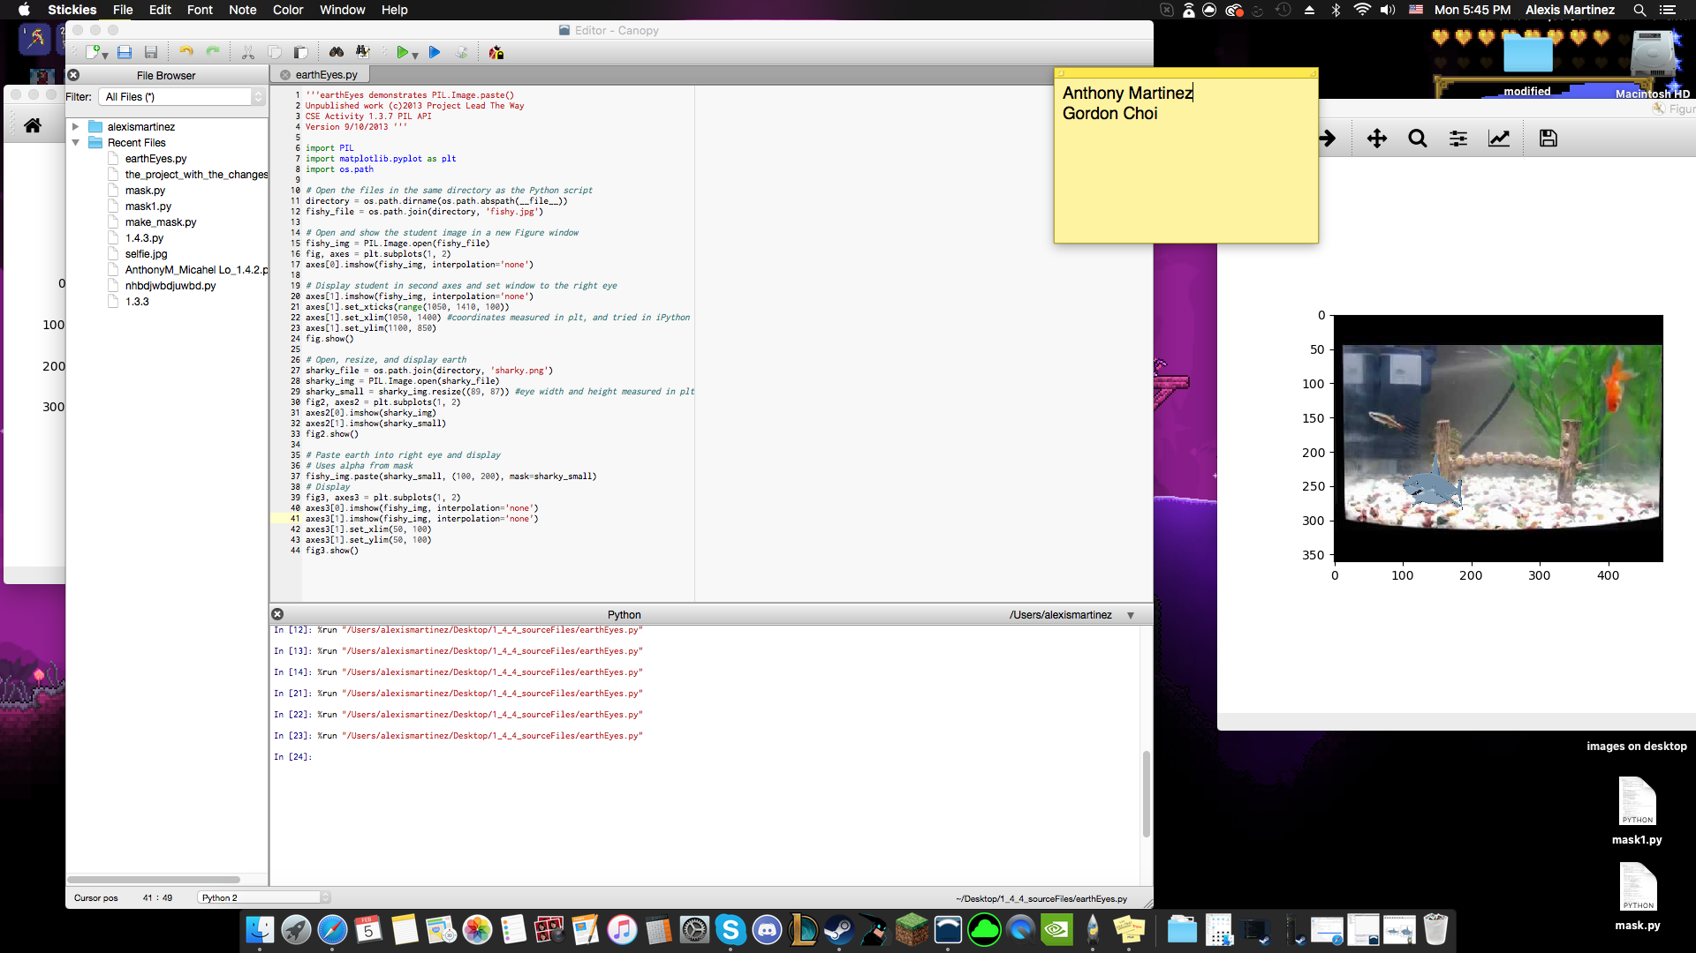

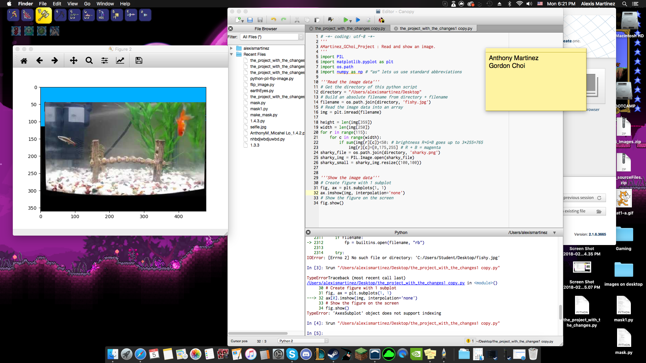

This added some blue to the black that is in the photo, making only the black top a certain type of blue.

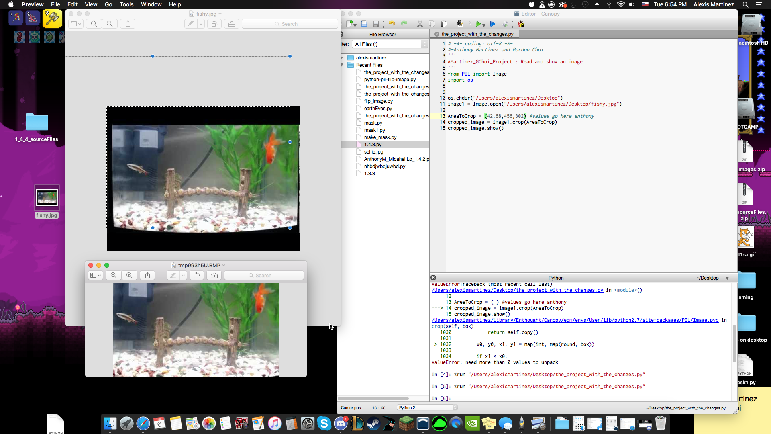



This changed cropped the photo to only show the fish tank and not the black outer rim of the photo.

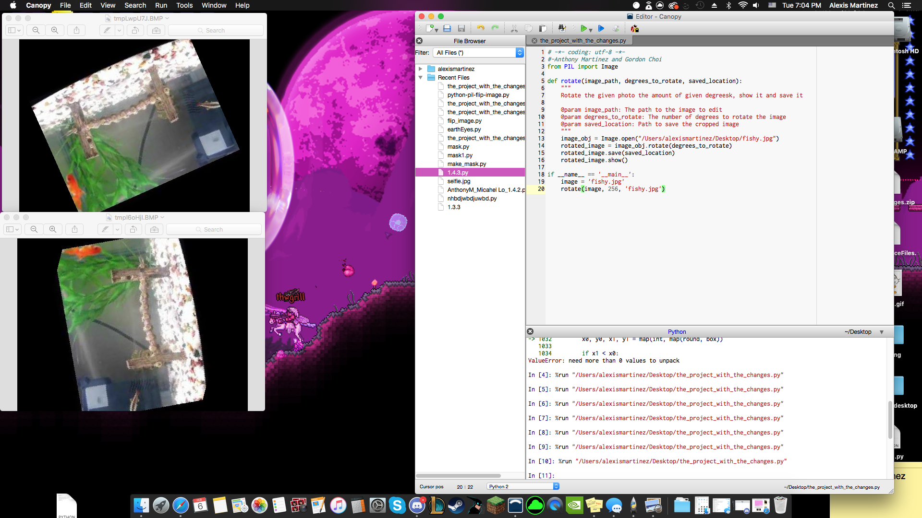

This here changed the photo to a certain degree that was inserted.



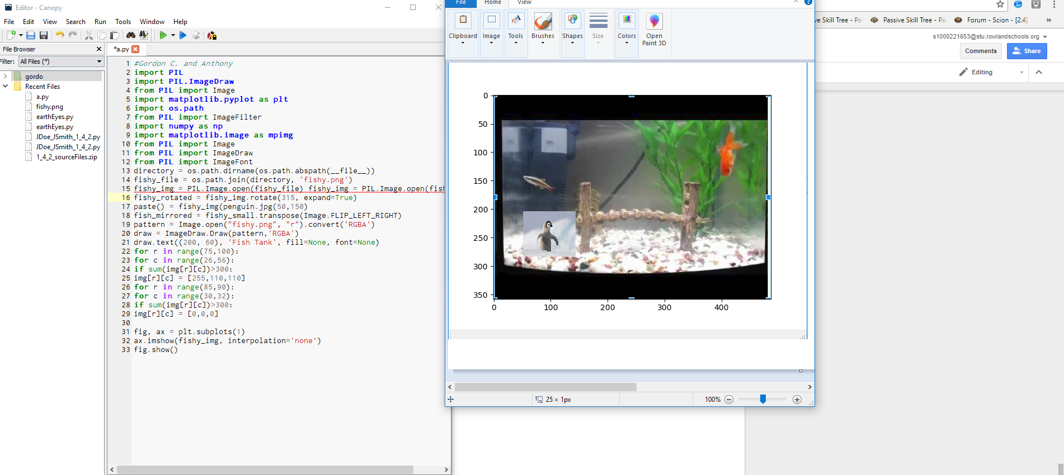

We added a penguin to the image next to the fishes.



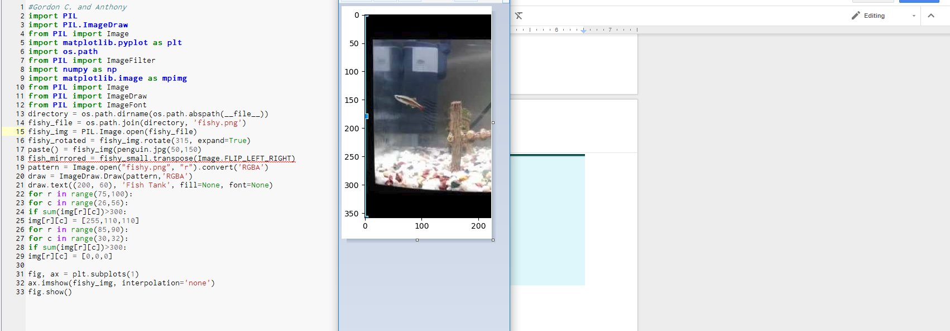

We cropped a fish out of the picture.



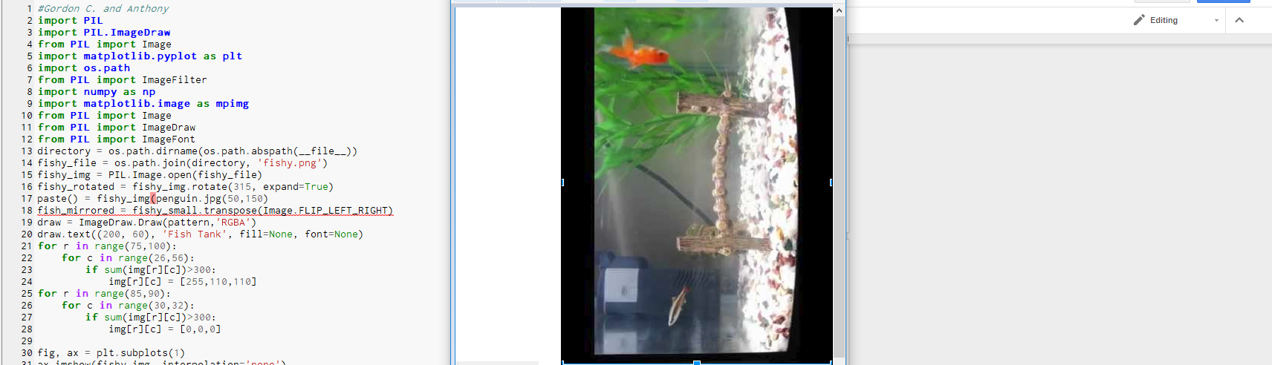

We rotated the image 90 degrees to the left



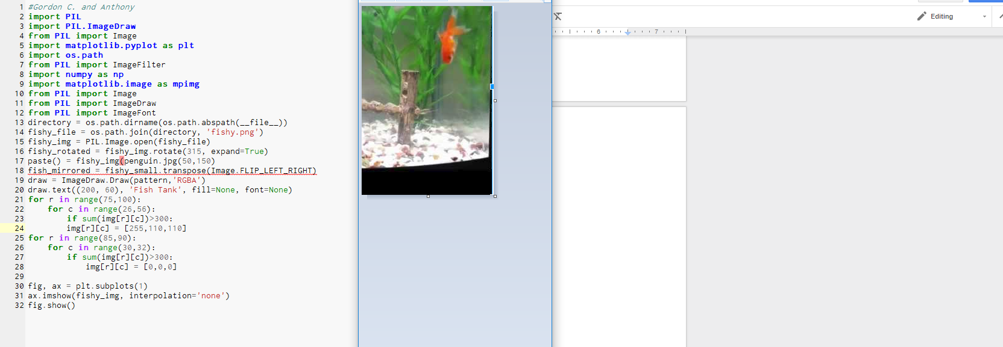

We cropped so that only the other fish was showing.